|  |  |
| --- | --- |
|  | **YEAR 12 MATHEMATICS SPECIALIST**  **SEMESTER ONE 2017**  **TEST 1: Complex Numbers** |

Name: _______________________

Thursday 9th March

**Time: 55 minutes Mark /50 = %**

* Answer all questions neatly in the spaces provided. **Show all working.**
* You are permitted to use the Formula Sheet in **both** sections of the test.
* You are permitted one A4 page (one side) of notes in the calculator assumed section.

**Calculator free section Suggested time: 20 minutes /20**

1. [11 marks]

Determine each of the following in rectangular form 

* 1. *z* if 

[3]

* 1. 

[3]

* 1. one solution to 

[2]

* 1. 

[3]

1. [6 marks]

 is a factor of.

* 1. Evaluate *p*

[2]

* 1. Rewrite  in the form 

[2]

* 1. Determine all solutions to 

[2]

1. 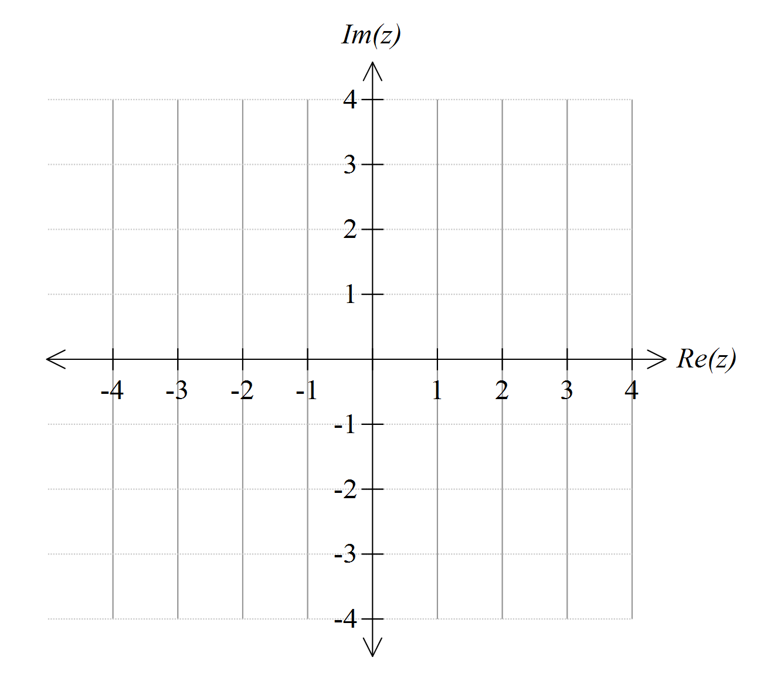 [3 marks]

When graphed on an Argand diagram, four of the solutions to  form a square with vertices , , and .

Evaluate *k* and then write down the remaining solutions to 

**Calculator assumed section Suggested time: 35 minutes /30**

Name: _______________________

1. [4 marks]

 and 

For which values of *n*, , will  be real?

1. [4 marks]

Determine, in Cartesian form , all solutions to the equation 

1. [12 marks]
   1. On the Argand diagrams given, sketch

(i)  [2]

(ii)  [4]



* 1. For the points defined in (i), determine the:

(iii) maximum value of arg(*z*) [1]

(iv) minimum value of arg(*z*) [3]

(v) maximum value of  [2]

1. [10 marks]

The line segments joining the points ,  and  form a triangle whose interior satisfies two inequalities:



and 

Determine:

* 1. the values of:  
      [2]  
      [2]  
      [2]  
      [2]
  2. the area of triangle *ABC*

[2]